

Sunday School Workshop:

**“Teaching Scripture; Changing Lives”**

Saturday 12th May 2018



Contents

Timetable 4

Vision and Values – Why we do what we do 4

Session 1: ‘The Destination of Transformation 6

A. What is Change? 6

Head Change 7

Heart Change 7

Hands Change 7

Reflection – What is Change? 7

B. Why does Change Matter? 8

Reflection – Why does change matter? 8

C. What Motivates Change? 9

3 False Motives: How not to motivate change… 9

3 Biblical Motives: How to motivate change… 10

Reflection – What motivates change? 10

D. Where Does Change Come From? 11

Reflection – Where does change come from? 12

Session 2: Planning for Change 13

A. Bible Passage – Acts 3 13

Some Questions to Consider: 14

B. Scripture Union Book – Session 8 (pg. 44-49) 16

Some questions to Consider: 16

Questions to Consider: 18

Session 3: Fostering a Culture of Change 20

3 Fatal Errors: How not to foster change 20

Setting an Example 21

Activity: The Fruit of the Spirit 21

Reflection – Setting an Example 22

Setting the Boundaries 23

7 Principles for Effective Behaviour Management 23

Appendix 24

Some helpful tips to remember while planning your lesson: 24

Activity List 26

VARK Learning Styles 28

Helpful Resources 29

# Timetable

09:30 - Welcome, Intro, Prayer

09:35 – **GDPR & Safeguarding:** Sunday School Registration Form for Guest

09:40 - **Vision and Values:** Why do we do what we do?

09:45 - **Prayer** for work as Sunday School Teachers

10:00 - **Session 1:** The Destination of Transformation

10:30 - Tea/Coffee Break

10:45 - **Session 2:** Planning Lessons that Change Lives

11:45 - **Session 3:** Fostering an Atmosphere of Change

12:30 - End

**In what ways does Scripture require ‘change’, and how do we teach to bring about change in the lives of the children?**

**4 Questions we should have answered by the end of today**

1. What is our motivation for Sunday school work?
2. What is biblical change and what motivates it?
3. How do we plan lessons that are focused gospel-change?
4. How do we prepare and deliver a fun, engaging lesson that commend this kind of change to the children?

# Vision and Values – Why we do what we do

“And beginning with Moses and all the prophets, Jesus explained to them what was said in all the scriptures concerning himself.” ~ Luke 24:27

**Vision: “Teaching the Gospel, Maturing Disciples, Changing Lives"**

By God’s grace and the Spirit’s power we will achieve this by:

1. **Providing** children with a welcoming, safe, fun and caring environment in which to learn and grow in the love and knowledge of Christ.
2. **Sustaining** a fully equipped, highly trained, diverse teaching team that serves with joy and passion.
3. **Ensuring** that the bible is always opened, taught faithfully and explained in a Jesus-centered way.
4. **Creating** a broad range of opportunities for both Christian and non-Christian children to hear the gospel and discover how it applies to their lives.
5. **Encouraging** and **supplementing** families in the spiritual care and ongoing discipleship of their children.
6. **Praying** earnestly both individually and as a team that the Holy Spirit would change the lives of Christian and non-Christian children through the power of the gospel to the glory of God.

**Why?**

* Gives a Biblical foundation
* Focus and Clarity

**How Will It Help Us?**

* Gives us a long view
* Identifies what is important to us
* Objective way of celebrating successes and identifying areas for growth
* A sense that we are stewards of something
* Gives guidance for our prayers

# Session 1: ‘The Destination of Transformation

***As Sunday School teachers you are inviting you children to come with you on a journey to a destination… The designation of transformation!***

“If you’re going to take your listeners to a destination, you need to make sure that the destination is worth going to! And can I suggest right now that there is only one destination worth taking people to? It’s a destination called “Change-ville”. It is the destination of gospel transformation… For your destination to be worthwhile and meaningful for your audience, something in them has to change. Something in their lives needs to be challenged to be different.” – Tim Hawkins[1]

**Four Questions Concerning Change**

A. What is change?

B. why does it matter?

C. What does and doesn't motivates change?

D. Where does change come from?

## A. What is Change?

**CHANGE**

Change is… “It is the difference that is the Holy Spirit produces in a child because they have engaged with God's word.”

That change occurrences in three places

* …
* …
* …

### Image result for brain line drawingHead Change

* Through ‘head change’ the Holy Spirit works to transform areas such as…
  1. ….
  2. ….
  3. ….
* Head change involves helping children growing the fundamentals of faith and the impact it has on them

### Heart Change

* Through ‘heart change’ the Holy Spirit works to transform areas such as…
  1. ….
  2. ….
  3. ….
* Heart change focus on what they want and what they want to be like

### https://art-catalog.org/wp-content/uploads/2018/04/hand-line-drawing-kimb7dqdt.jpgHands Change

* Through ‘hands change’ the Holy Spirit works to transform areas such as…
  1. ….
  2. ….
  3. ….
* Hands change focus on what they do and how they live

***These are the changes we want to see in children, because these are the changes we want to see in all Christians, and especially in ourselves.***

### Reflection – What is Change?

How often do you think about the change you want your lesson to produce when you are planning for Sunday School?

Order head, heart, and hand change (below) based on which usually gets the most air time in your lessons:

1. ………………………….. (most focus)
2. …………………………..
3. ………………………….. (most focus)

## Image result for sync symbol line drawingB. Why does Change Matter?

Change matters because?

* 1. …….
  2. …….

**Becoming a Christian = Change (Regeneration)**

*"But because of his great love for us, God, who is rich in mercy, made us alive with Christ even when we were dead in transgressions...." -* Ephesians 2:4-5

* What change does the Holy Spirit work in us when we trust in Jesus and repent of sin?

**The Future of a Christian = Change (Glorification)**

*"* *Dear friends, now we are children of God, and what we will be has not yet been made known. But we know that when Christ appears, we shall be like him, for we shall see him as he is.”* – 1 John 3:2

* What change will occur in us when Jesus returns?

**Being a Christian = Change (Progressive Sanctification)**

*"All who have this hope in him purify themselves, just as he is pure”* – 1 John 3:3

* What ongoing change are we to seek the Holy Spirit to work in us in the meantime?

Change matters is one of the primary ways God brings himself glory in the life of a Christian and the salvation of a Non-Christian (Romans 8:29-30; Ephesians 1:3-14; Phil 2:12-13, etc.).

**Change matters because God’s glory matters**

### Reflection – Why does change matter?

To what extent do you make on going change (progressive sanctification) an priority in you walk with God? Why/why not?

## C. What Motivates Change?

To motivate change we need to give the children a reason to change!

Ask yourself: “Based on this passage…”

* Where do I need to change?
* Where do they need to change?
* What reason are we given to change?

### Image result for cheerleader pom pom line drawing3 False Motives: How not to motivate change…

**The Cheerleader Approach**

* Tries to bring about change by positivity and inner-strength
* Might work in the short term but never lasts
* Teaches children to look inward to trust themselves, not outward to trust God
* Rarely mentions sin or its consequence

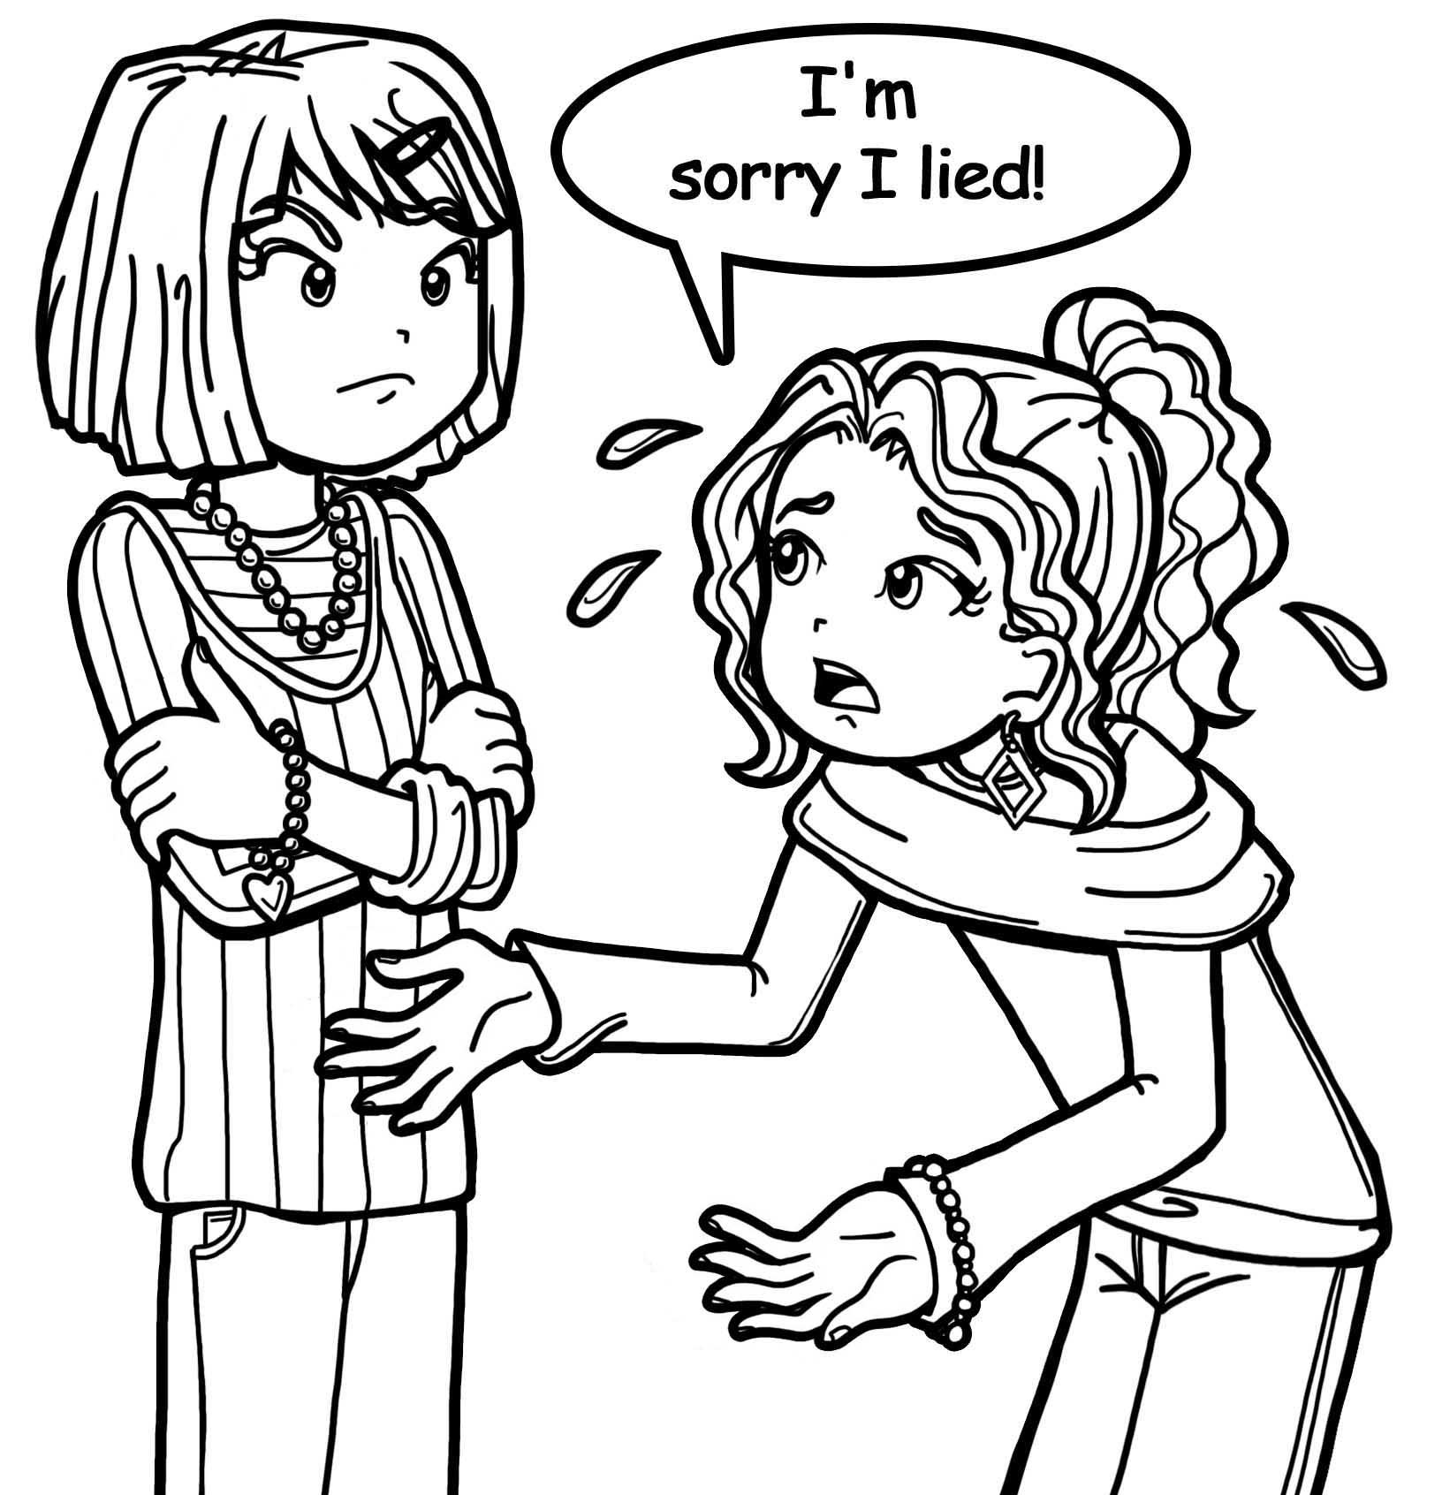

**The Parent Approach**

* Tries to motivate change through morality (this is good, do that / that is bad, don’t do it)
* Forgets that most now see morality as subjective (e.g. good for me, bad for you)
* In Scripture goodness and badness are tied to God’s character
* Tries make bad children good and good children better without the gospel.

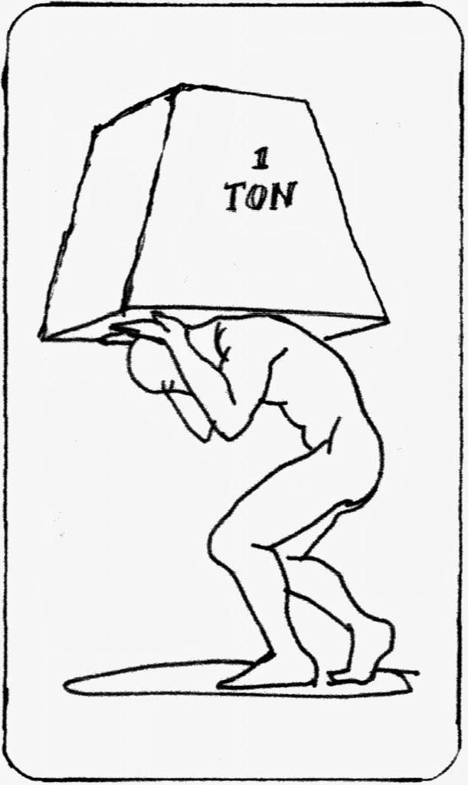**The Oxfam Approach**

* Tries to motivate change through guilt (‘if you really loved God…’ or ‘Think of all the nice things you have, and *they* have nothing…’ )
* Short-term effect, eventuality they stop caring
* Sounds self-righteous
* Must ramp up the guilt each time to have an effect

**Each of these examples misunderstands how biblical change is produced.**

### 3 Biblical Motives: How to motivate change…

**Conviction of Sin**



* Diagnoses the sickness (Sin) and presents the treatment (the Cross)
* *"Therefore, let all Israel be assured of this: God has made this Jesus, whom you crucified, both Lord and Christ. When the people heard this, they were cut to the heart and said to Peter and the other apostles, “Brothers, what shall we do?”"* – Acts 2:36-37
* Focuses on the root of action not action itself
* Presents Jesus death and resurrection as a lasting solution



**The Grace of God**

* *“But he gives us more grace. That is why Scripture says: “God opposes the proud but gives grace to the humble.”* – James 4:2
* Knowing an all-powerful God is willing to help if we ask is a powerful motive
* Calls us to look outward for strength to change, not inward

**Thankfulness**

* “Therefore, I urge you, brothers and sisters, in view of God’s mercy, to offer your bodies as a living sacrifice, holy and pleasing to God—this is your true and proper worship. Do not conform to the pattern of this world, but be transformed by the renewing of your mind.” – Romans 12:1-2
* Out of gratitude we give our all to God, when we understand how he has given his all for us!
* Gratitude is a motive that is biblical, powerful, gospel-focused, and positive.

**Biblical motives for change encourage biblical change!**

### Reflection – What motivates change?

Underline one of the false motives for change that you might find most tempting to use with children?

Underline one of the biblical motives for change that you could use instead?



## D. Where Does Change Come From?

**What brings about change in a child’s life?**

**Think Change; Think S.I.S**

**S**OURCE of CHANGE

**I**nstrument(s)

of CHANGE

**S**UBJECT of CHANGE

**Sunday School Teacher and Lesson as Instruments of Change**

See our work as Sunday School teachers as instruments of change is both…

1. …………………..
2. ………………….

**You and your Lesson are two powerful instruments that the Holy Spirit can use to bring about change (Gospel-transformation) in the lives of children.**

### Reflection – Where does change come from?

To what extent does the Holy Spirit feature when helping the children apply a passage tom there lives?

How will knowing you are someone the Holy Spirit can use to change lives change how you teach and prep?

# Session 2: Planning for Change

This session is designed to equip you to better able to:

* **examine** a scripture passage
* **identify** the change it calls for
* **evaluate** curriculum material based on your findings
* **create** a lesson plan that promotes change in the children.

## A. Bible Passage – Acts 3

Acts 3:1-26

One day Peter and John were going up to the temple at the time of prayer—at three in the afternoon. 2 Now a man crippled from birth was being carried to the temple gate called Beautiful, where he was put every day to beg from those going into the temple courts. 3 When he saw Peter and John about to enter, he asked them for money. 4 Peter looked straight at him, as did John. Then Peter said, “Look at us!”

5 So the man gave them his attention, expecting to get something from them. 6 Then Peter said, “Silver or gold I do not have, but what I have I give you. In the name of Jesus Christ of Nazareth, walk.”

7 Taking him by the right hand, he helped him up, and instantly the man’s feet and ankles became strong. 8 He jumped to his feet and began to walk. Then he went with them into the temple courts, walking and jumping, and praising God. 9 When all the people saw him walking and praising God, 10 they recognized him as the same man who used to sit begging at the temple gate called Beautiful, and they were filled with wonder and amazement at what had happened to him.

11 While the beggar held on to Peter and John, all the people were astonished and came running to them in the place called Solomon’s Colonnade. 12 When Peter saw this, he said to them: “Men of Israel, why does this surprise you? Why do you stare at us as if by our own power or godliness we had made this man walk? 13 The God of Abraham, Isaac and Jacob, the God of our fathers, has glorified his servant Jesus. You handed him over to be killed, and you disowned him before Pilate, though he had decided to let him go. 14 You disowned the Holy and Righteous One and asked that a murderer be released to you. 15 You killed the author of life, but God raised him from the dead. We are witnesses of this. 16 By faith in the name of Jesus, this man whom you see and know was made strong. It is Jesus’ name and the faith that comes through him that has given this complete healing to him, as you can all see.

17 “Now, brothers, I know that you acted in ignorance, as did your leaders. 18 But this is how God fulfilled what he had foretold through all the prophets, saying that his Christ would suffer. 19 Repent, then, and turn to God, so that your sins may be wiped out, that times of refreshing may come from the Lord, 20 and that he may send the Christ, who has been appointed for you—even Jesus. 21 He must remain in heaven until the time comes for God to restore everything, as he promised long ago through his holy prophets. 22 For Moses said, ‘The Lord your God will raise up for you a prophet like me from among your own people; you must listen to everything he tells you. 23 Anyone who does not listen to him will be completely cut off from among his people.’

24 “Indeed, all the prophets from Samuel on, as many as have spoken, have foretold these days. 25 And you are heirs of the prophets and of the covenant God made with your fathers. He said to Abraham, ‘Through your offspring all peoples on earth will be blessed.’ 26 When God raised up his servant, he sent him first to you to bless you by turning each of you from your wicked ways.”

### Some Questions to Consider:

* What are the main events of the passage?
* What is the main point of the passage?
* What change might the passage be calling for?
  + Head change?
  + Heart change?
  + Hands change?
* What will motivate this change in you and those in your class?

**Space for more notes if you need them ☺**

## B. Scripture Union Book – Session 8 (pg. 44-49)

Based on your findings from Acts 3, **evaluate** the Scripture Union material, and consider what changes/modification you might need to do to communicate the changes the passage is encouraging.

### Some questions to Consider:

* Take a look at the summary material at the top of page 44. To what extent are they expecting a change to take place in the children because of this lesson? If so, what is it?
* Can you identify the three areas of change here (head, heart, hands?)
* What motivation (if any) are they suggesting will motivate the children to change?
* How does their change expectations and suggested motivation compare to your findings from Acts 3? What is similar? What is different?
* What improvements/alterations would you make here to bring it in line with your findings from Acts 3?
* Get each person on your table to pick one activity from either “options to open” (pg. 44) **OR** “into the Bible (pg. 45-46) **OR** “Living the Life” (pg. 47). Consider the activity based on your findings.
  + How effectively does it communicate the change and motive for change the passage requires?
  + How would you adapt it or doing something different in its place to ensure that these things are communicated?
* How will you wrap up the lesson ensure that everyone leaves knowing…
* What the passage was about and how we are to change because of it?
* What is supposed to motivate that change?
  + Where to look for that change to happen (I.e. The Holy Spirit)?

**Space for more notes if you need them ☺**

C. Lesson Plan – Outline

### Questions to Consider:

* Looking back on your notes from Part A what main point from the passage do you want the children to learn?
* How will you rephrase this simply, but without watering it down? – You could turn this into a ‘key question’ or a ‘big idea’.
* How do you expect your children to be changed (head, heart, hands) by this lesson? What will motivate that change? Write it out alongside your key question/big idea so that it is prominent in your planning.
* What activities will you use and why? How will they help teach the children the main point/big idea? You may want to think about how you will structure your lesson here and how much time you would allocate to each activity?
* How will these activities communicate the change you want to take place and the motive for that change? (The list of activities at the back of this booklet and the box resources of your table are designed to get your creative juices flowing!)
* How are you going to make sure that the children in the group have understood the lesson, your big idea, and how it impacts their head, heart, and hands?
* Based on your main point, how will you ensure that the children understand that it is only through the Holy Spirit that they are able to live/change?

**Space for more notes if you need them ☺**

# Session 3: Fostering a Culture of Change

This final session looks at three things

1. How not to foster change
2. How to set an example that encourages change
3. How to set boundaries that promote change

## 3 Fatal Errors: How not to foster change

Often creating an incorrect environment for change stems from an incorrect view of the children. Here are three fatal errors in thinking to avoid…



**1. Jarheads**

* See’s children as empty vessels to be filled
* Fails to appreciate that no child is neutral to faith
* All children bring their own values, views, and assumptions from home and culture
* Forgets that children have much to tech *us* about faith and obedience (Mark 10:15



**2. Pet Projects**

* Usually a very good child and/or a very bad child
* The child is treated markedly differently to others in the class (E.g. Always asked first for answer vs. never asked)
* Fails to see that morality and godliness are different
  + A ‘bad child’ may trust Christ but struggle with change
  + A ‘good child’ may be trusting in self-righteousness and inwardly hate Christ.
* It commits the sin of favouritism (James 2:1)

**3. Mr. Fix It**



* Only sees children as problems to be ‘fixed’
* Often results in sweeping judgments on children or parents (E.g. “There problem is they do X / Just need to do Y”
* Fails to see children as people, or as more than the sum of their issues
* Seeks behaviour modification and not gospel-change
* Seeks change through works righteousness

## Setting an Example

**YOU**

The journey towards creating an environment that fosters change begins before a child enters Sunday School.

It starts with us setting an example worth imitating.

As a Sunday school teacher, you inhabit three important ministry roles in the life of the children you teach.

They are: (label the diagram if that helps)

1. ……………….
2. ………………
3. ………………

For children under 11, you are one of the biggest influences in shaping their view of godly Christian maturity.

**Few things harden a person’s heart to the gospel like ministry hypocrisy.**

### Image result for orange segments line drawingActivity: The Fruit of the Spirit

One way to set an example as Sunday School teachers is to visibly display the fruit of the Spirit.

"The fruit of the Spirit is love, joy, peace, patience, kindness, goodness, faithfulness, gentleness and self-control." – Galatians 5:22

The Fruit of the Spirit are not a series of fruits, but all parts that make up one fruit (think segments of an orange!)

Here what you need to do:

* Select one of the parts of the fruit of the Spirit in column 1 (eg. Love)
* In column 2 write some ways in which this virtue might express itself in you as a Sunday School teacher (eg. Sharing the gospel.
* When you have a few examples, move on to the next one
* If you complete the list, begin again with examples for a child’s life.

|  |  |  |
| --- | --- | --- |
| **Fruit of**  **the Spirit** | **Your teaching Practice** | **Child’s Life** |
| Love |  |  |
| Joy |  |  |
| Peace |  |  |
| Patience |  |  |
| Kindness |  |  |
| Goodness |  |  |
| Faithfulness |  |  |
| Gentleness |  |  |
| Self-control |  |  |

### Reflection – Setting an Example

Consider the three errors in fostering change (Jarhead, Pet Project, Mr. Fix It). Of these three is there one you most often struggle with as a teacher?

Which of the fruit of the Spirit is most evident in your life right now? Which is least evident?

## Image result for fence line drawingSetting the Boundaries

Fostering change is about giving children an example to follow, and teaching them what to avoid

In the life of a child what two things can we do something about?

1. ……………..
2. ……………….

Only the Holy Spirit can do something about these two areas!

What one thing can we help children with?

1. …………………..

When addressing behaviour with a child directly always try to.

1. Identify the boundary of behaviour which has been crossed
2. Provide a biblical explanation for the sin they have committed
3. Explain what needs to change

Example:

*"When God speaks in the bible it is always true, and always for our good. Loving God and loving our neighbour means only speaking to others what is good for them and what is true about them."*

Sometimes a quick word might be enough. Other times (e.g. Fighting, mean language) something more is need.

If that’s not working, try and speak to the parents, preferably dad, or both together if possible

In extreme cases, speak to the Family Pioneer and we’ll think through an action plan (ensure you’ve done the above first!)

### 7 Principles for Effective Behaviour Management[2]

1. Be consistent
2. Be age-appropriate
3. Be fair and just
4. Be Child-specific
5. Be Forward Looking
6. Be Relational
7. Be Dependant on the Holy Spirit

### Activity: Addressing Behaviour to Promote Change

* Look at the examples below, what could you do to address the behaviour?
* What will you say? When? Where? And how?
* Could the situation have been prevented if the issue had been addressed earlier? If so, how?
* How will you ensure you do so in away that promotes change in the child’s life?
* Where appropriate, how will you help them see
  + Where they’ve crossed boundary
  + How to identify their sin
  + What they need to do about it
* How will you provide a motivation for that change?

**Examples to consider:**

1. A new child joins your class. They are attending church for the first time today. They struggle to engage and appear bored and uninterested for most of the lesson. Towards the end of the class they begin distracting and disrupting other children. What do you do?
2. Two children enter you class talking about the latest craze sweeping their school. They continue talking about it as your trying to explain an activity, and during the activity their conversation begins to draw in and distract other children in the room. How would address this situation?
3. You woke up late this morning and so had to set up in a rush. The photocopier in the office kept jamming and you had to change a key part of the lesson at the last minute because you forgot a resource. One child, whom you find particularly difficult keeps causing problems in the lesson. After speaking to them serval times, you eventually snap at them verbally. The child doesn’t cry but is visibly reserved for the remainder for the lesson. What could you do?
4. A usually model child enters the classroom in a foul mood and sulks for most of the lesson. When it comes time for the craft activity the child refuses to take part. You normally get on well with this child but today the more you ask them to take part, the angrier they become. How will you resolve the dilemma?
5. One child in your class is particularly chatty. However, whenever you attempt to address the child’s behaviour with them they get upset and start to cry. What are you to do?

**Space for more notes if you need them ☺**

***Thank you for giving up your time and attending the workshop today – I really appreciate all of the hours you put in in teaching our children the truth of God’s word!***

# Appendix

## Some helpful tips to remember while planning your lesson:

* Try to make sure that the lesson has **structure**; a clear beginning, middle and end.
* How will you ensure that the **change** required is covered in your lesson?
* Think about what you want the children to **learn** (sometimes it’s helpful to phrase the big idea of the story as a question).
* Make the most of the **other teacher**: For this task, the class will have you (the teacher) and another teacher.
* Try to use memory verses in a way that ensures children understand its ***meaning***not just what it says.



* Try to make sure that children understand that it the **gospel** that will change them and not moral behaviour, guilt, or positive thinking.
* How will you relate the **CHANGE** to **HANDS** and **HEARTS**? How will you use scripture and sound doctrine to ground this in their **HEADS**?
* Try to make sure that you have some way to measure whether the children have **understood** how they are expected to change from the lesson, and why.
* Think about the ways in which you want the children in your group to be different by the end of your lesson – use the **head, heart, hands** to guide your **prayers** for them.
* Try to have on going conversations with **parents**. Think about ways the ways that you can creatively involve parents in their children’s learning without setting formal, written homework!
* Have a think about the **different children** in your group. Do they have any specific preferences or learning difficulties? Are there ways in which you can specifically tailor your lesson to the children in your group?
* What are their passions, gifts, and talents? What relationships do they have with others? Where has God placed them? **(Hands)**
* Use resources from a variety of different sources, some examples are activities and resources are towards the back of this booklet. Try to use activities to **bring about learning** and **encourage change.**

## Activity List

Here is a list of some possible activities that you may wish to use in your lesson in order to bring about learning. It is definitely not an exhaustive list, but may help get your ideas flowing!

Memory Verse

Games

Drama

Craft – individual/group

Prayer

Individual Reflection

Quiz

Puzzle

Fill in the blanks/Cloze

Putting the story in the right order/Story board

Song

Colouring/Art

Creative Writing/Poetry

Video/Multimedia

Treasure Hunt/Clues

Card Sort

Using outdoor/different spaces



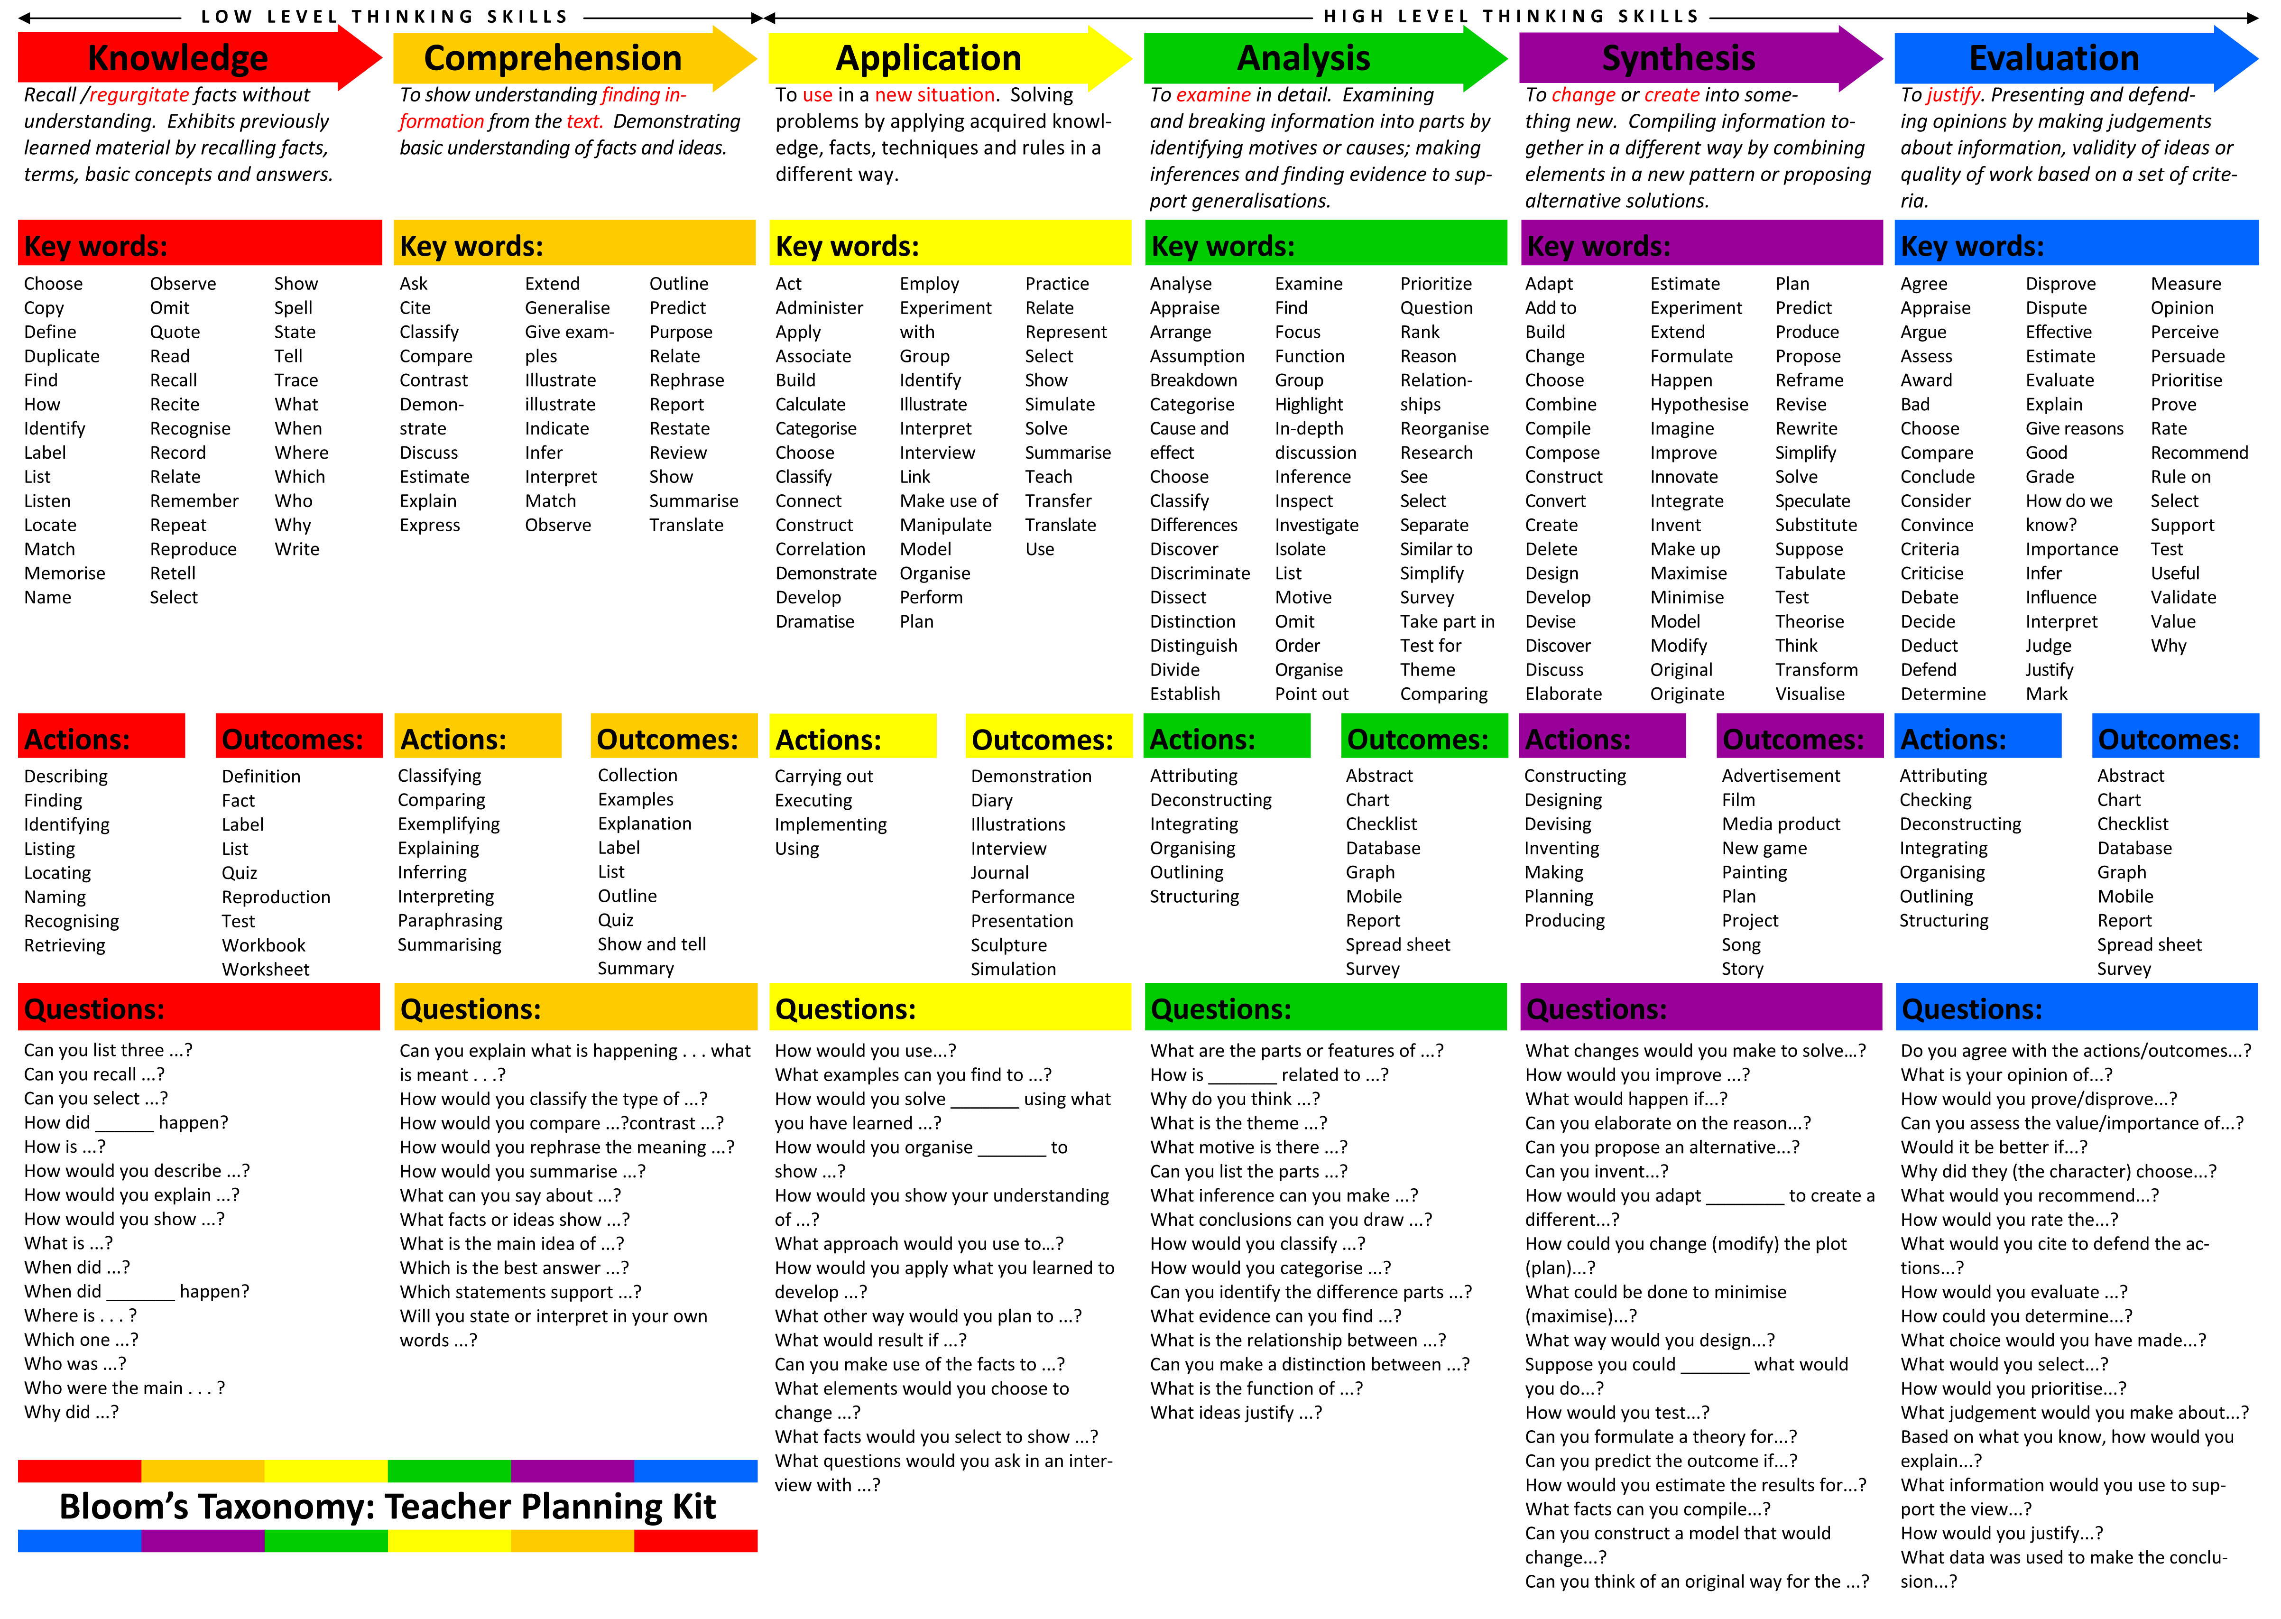Discussion/Questions

## VARK Learning Styles

When it comes to learning, individuals have their unique personal way to grasp and absorb things around them. Most people fall into four main categories of learners or a combination of two or more, depending on their style and orientation. These four categories are V-A-R-K;

**V**: Visual

**A**: Aural/Auditory

**R**: Read/Write

**K**: Kinesthetic

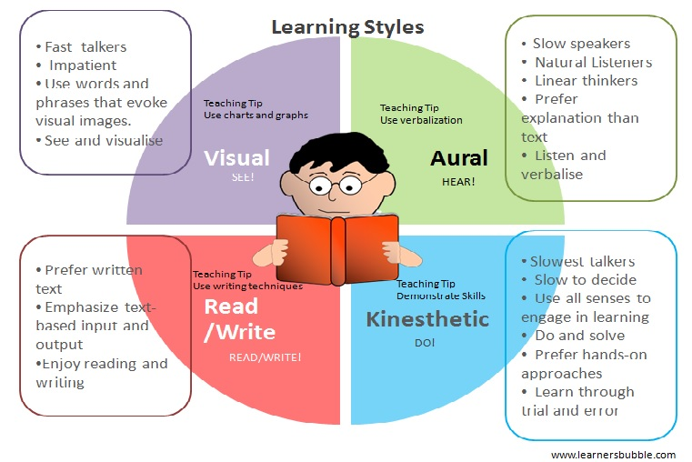As their names suggest, Visual learners learn best by seeing/witnessing, Aural learn best through their listening sense; Read/Write learners learn best by reading text and exercising writing; and Kinesthetic learners learn best when they can touch and feel or do things that are taught. These four categories of learners have certain characteristics specific to them.

## Helpful Resources

Bibles

* *The Jesus Story Book Bible*: Sally Lloyd Jones, Zondervan
* *The Beginners Bible*: Timeless Children’s Stories, Candle Books

Bible overview in Story Form

* *The Garden, The Curtain and the Cross*: Carl Laferton, The Good Book Company
* *The Biggest Story: How the Snake Crusher Brings Us Back to the Garden*, Crossway

Systematic Theologies

* *The Ology*: Ancient Truth Ever New: Marty Machowski, New Growth Press. (The CD that goes with it by Sovereign Grace is also really good!)
* *Kenneth Taylor, Everything a Child Should Know About God, 10Publishing, 2014*
* *Tim Challies, Visual Theology, Zondervan, 2016*

Books on Children’s Work

* *Show them Jesus*: Klumpenhower, New Growth Press

Books on General Bible Study/Exploring Passages

* *Digging Deeper: Tools for Understanding God’s Word*: Beynon & Sach, Crossway
* *The Bible Book: A User’s Guide*: Nick Page: Collins
* *Grasping God’s Word:* Duval & Hays, Zondervan

Books on Ideas for Games

* *The Encyclopaedia of Bible Games for Children’s Ministry,* Group Pubishing
* *Fill the Gap:* Rebecca Parkinson, Barnabus for Children

Children’s Devotionals

* *Thoughts That Make Your Heart Sing, Sally Lloyd Jones, Zonderkidz*

Online Resources

* <http://www.freebibleimages.org/> - illustrations and pictures of Bible Stories
* <http://www.bricktestament.com/home.html> - Bible Story images created in Lego!
* <http://www.sermons4kids.com/> - all sorts of resources – some good, some not so good!
* <http://www.familytrust.org.uk/resources.php>
* <https://www.premierchildrenswork.com/Resources> - Some free resources, others incur a cost
* <http://www.bristol.anglican.org/i/wpcontent/uploads/2011/06/Creative_Prayer_ideas.pdf> - Some creative prayer resources
* <http://flamecreativekids.blogspot.co.uk> - craft resources
* <http://www.daniellesplace.com/> - craft resources
* <http://thebeginnersbible.com/parents-teachers.php> some good resources, especially for colouring and puzzles
* <https://www.youtube.com/playlist?list=PL88C6294EBFC555EA> - Zondervan’s “Children’ Youtube playlist including some animated versions of the Jesus Storybook Bible Chapter

1. Tim Hawkins, Messages that Move: How to give Bible talks that challenge and inspire (Electronic Ed.), Epsom: The Good book Company, 2013, np.
2. Adapted from “Principles or Parental Discipline” in Andreas J. Köstenberger, *God, Marriage, and family: Rebuilding the Biblical Foundation*, Wheaton: Crossways Books, 2004, 160-162